Sonarcloud

1)download sonarcloud and make account

2)and then go to azure devops and create project and make it public

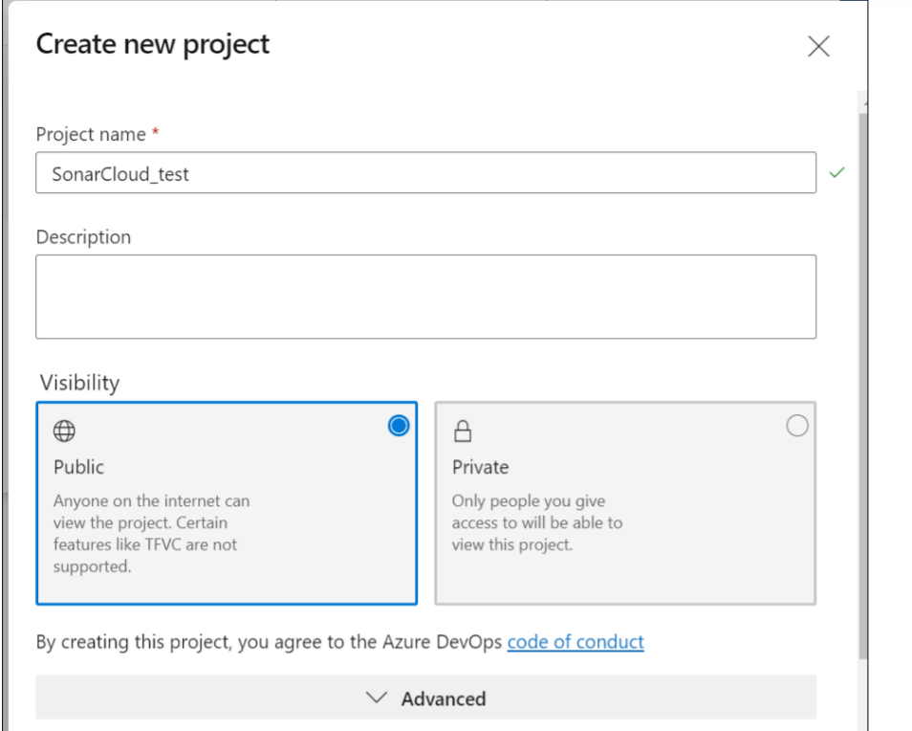

3)then copy the github link where the code is present and then in azure import the repository

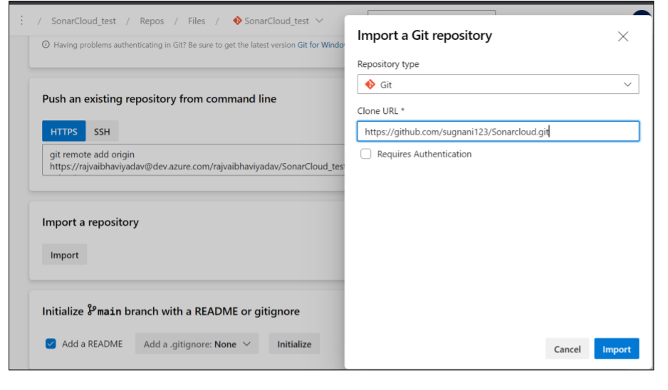

4)then go to sonarcloud and select organization and then select available repository and then add personal token from service connection in azure devops.

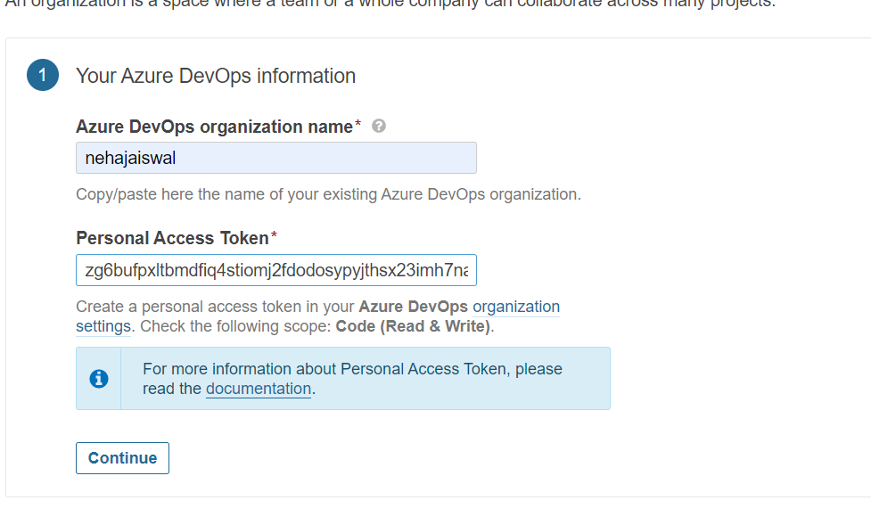

5)then install extension of sonarcloud select organization and install it

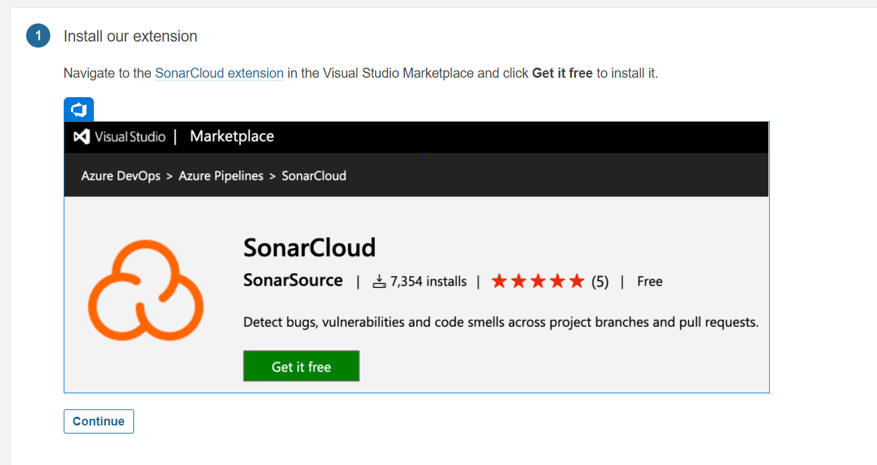

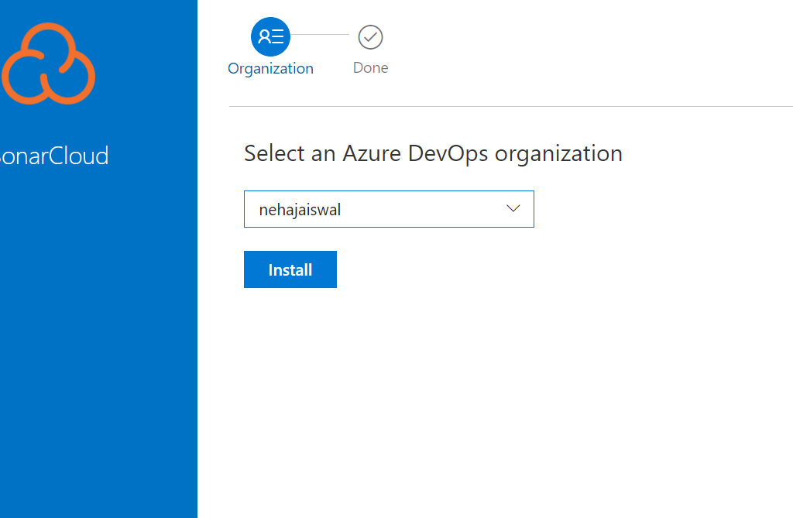

6)then in 2nd step select language in which your code is in

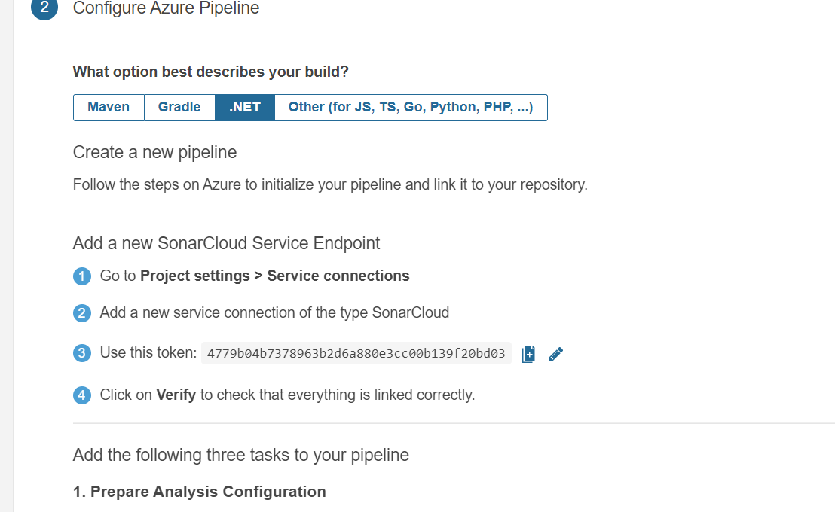

7)fill above information in service connection by creating service connection search sonar cloud

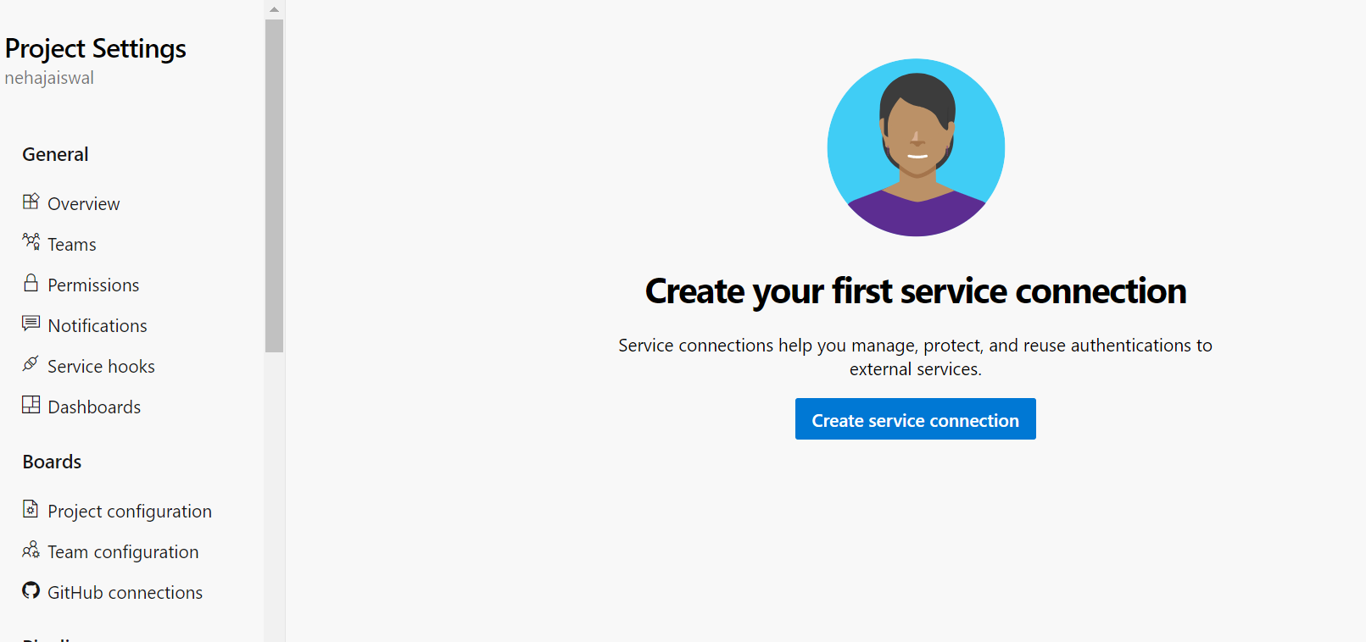

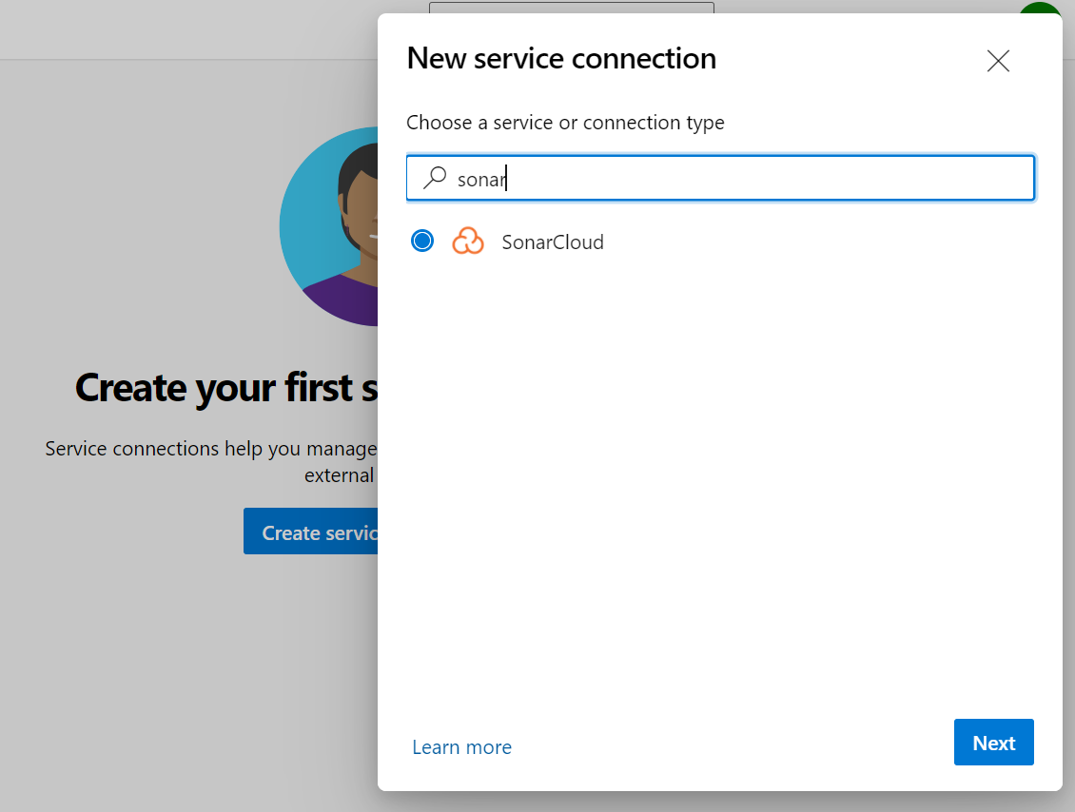

8)copy the token from sonar cloud and paste here and verify

Write service connection name and verify and save

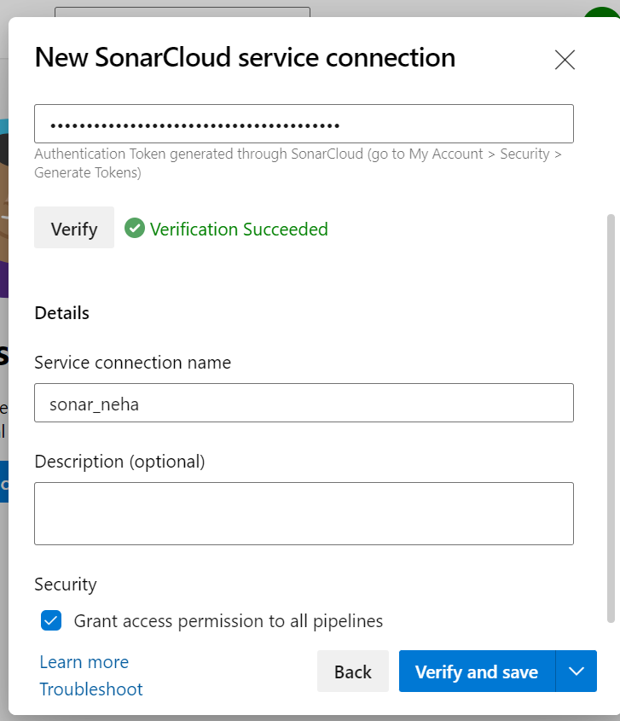

9)then go to pipelines and select use the classic editor to create pipeline

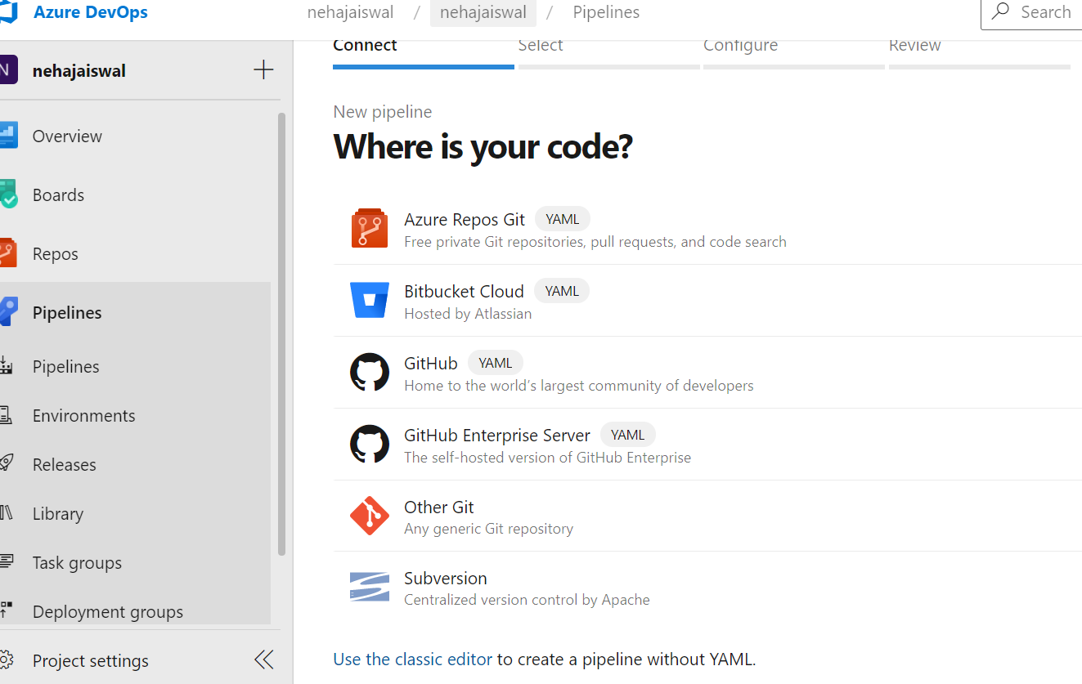

10)select azure repos git and add your repository which you are imported before and continue

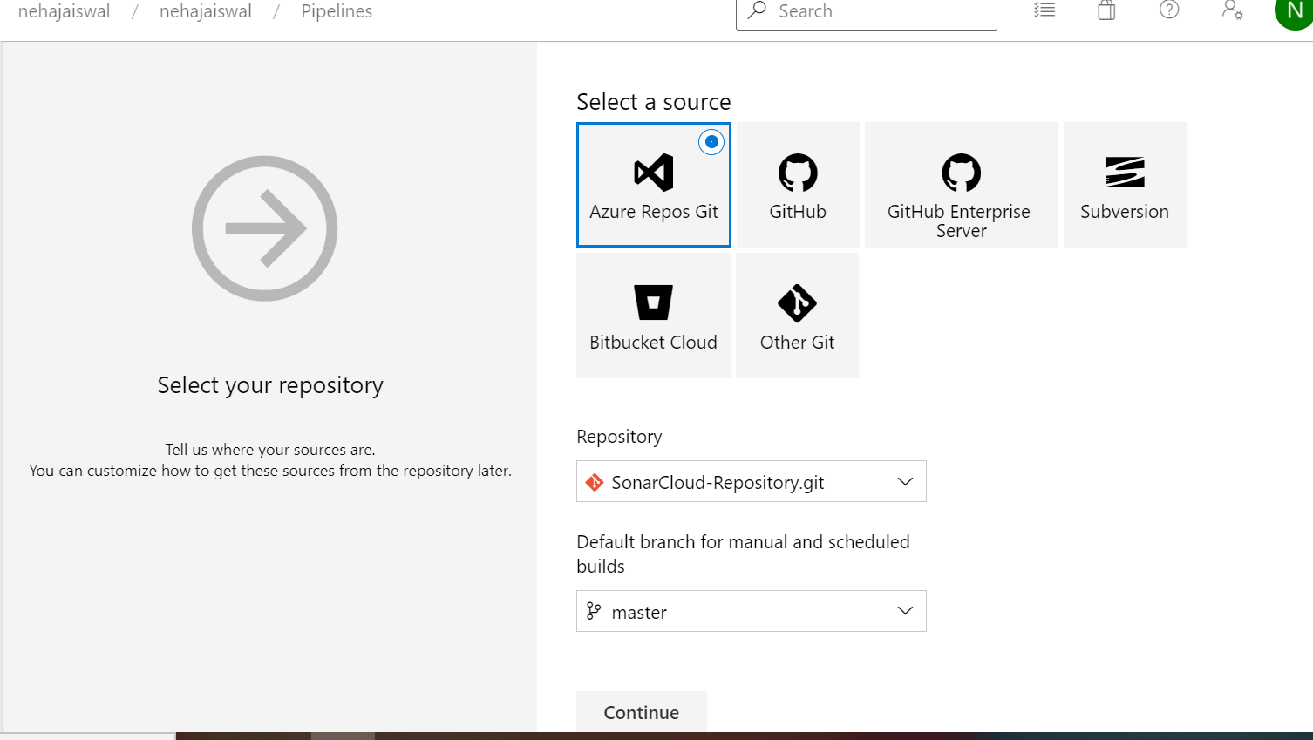

11)select template ASP.NET

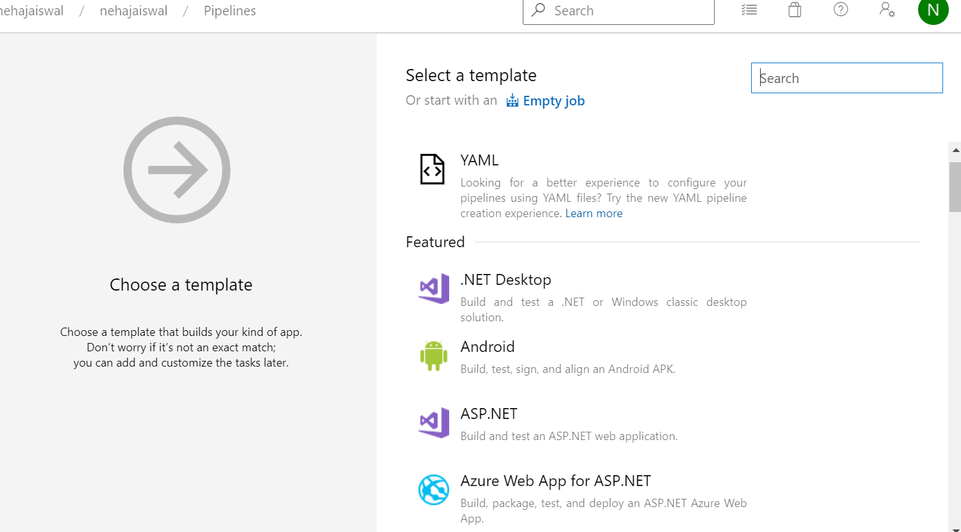



12)then choose integrate with ms build add 3 things

1)prepare analysis on sonarcloud

-add project name and project key from sonarcloud

2)then build solution

3)publish quality gate result

4)run code analysis

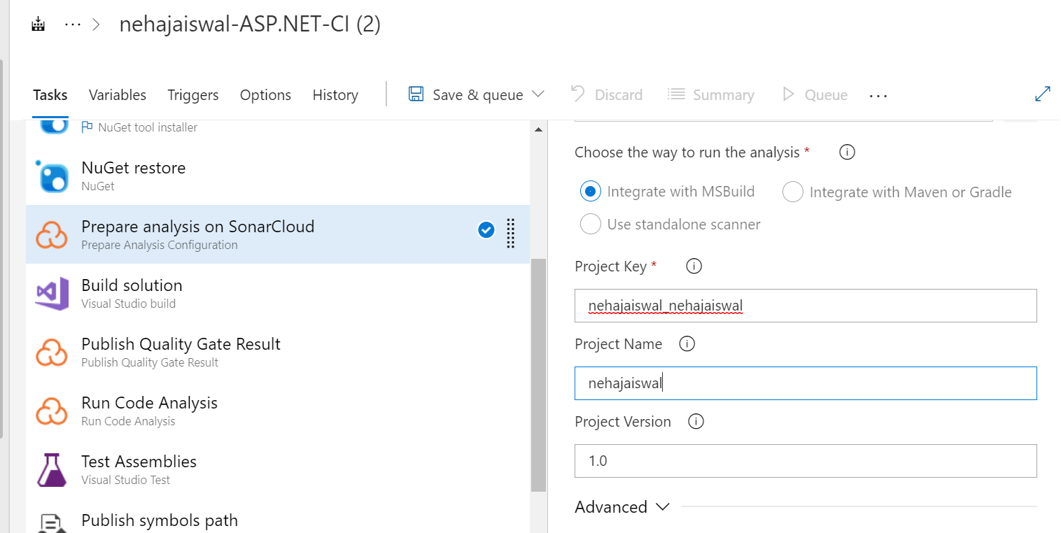

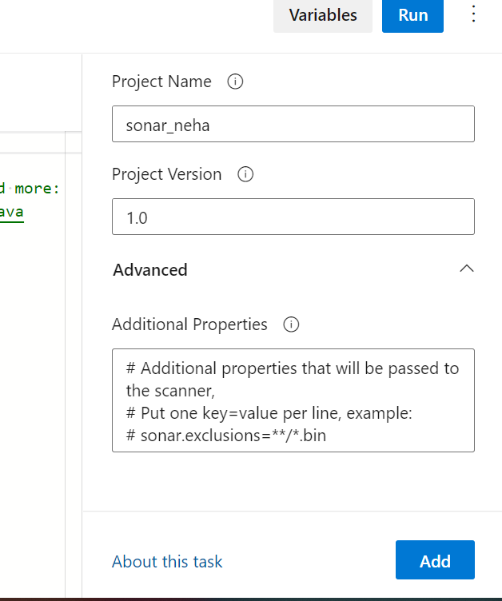

Then save and queue

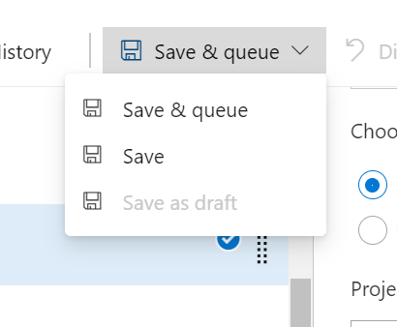

13)run pipeline using save and run

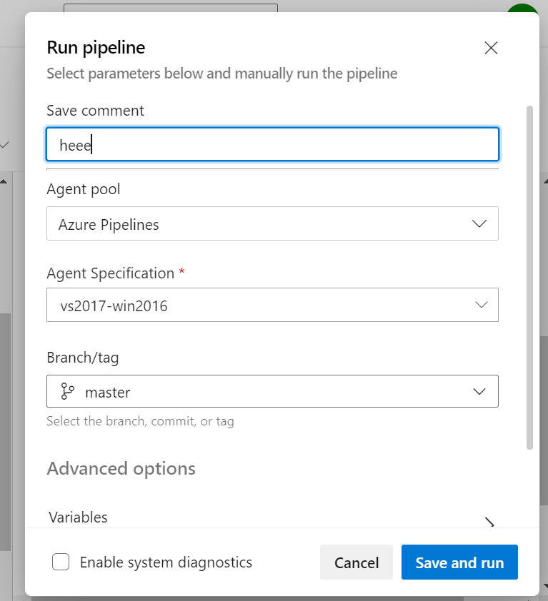

**14)then it will run all files**

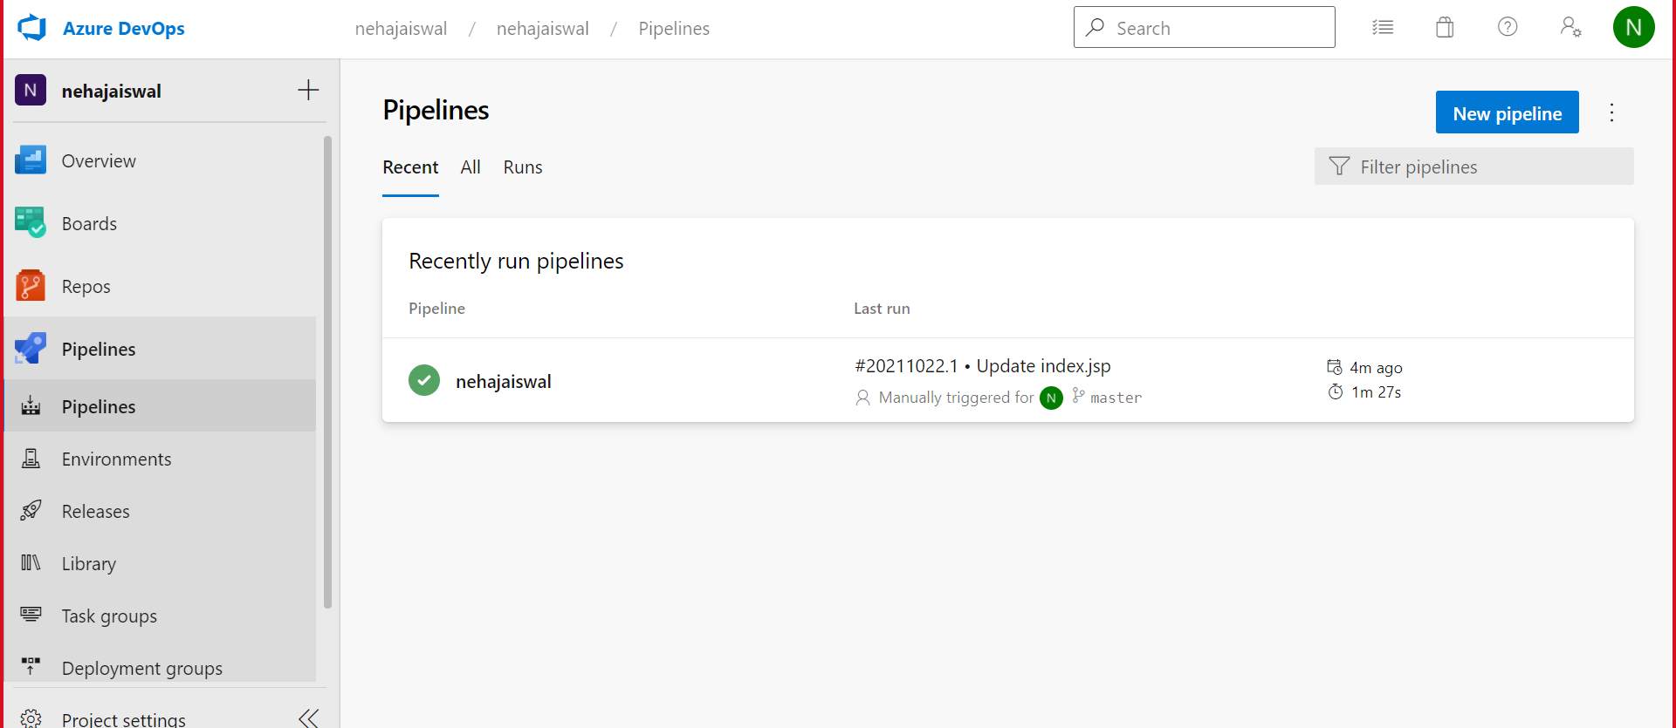

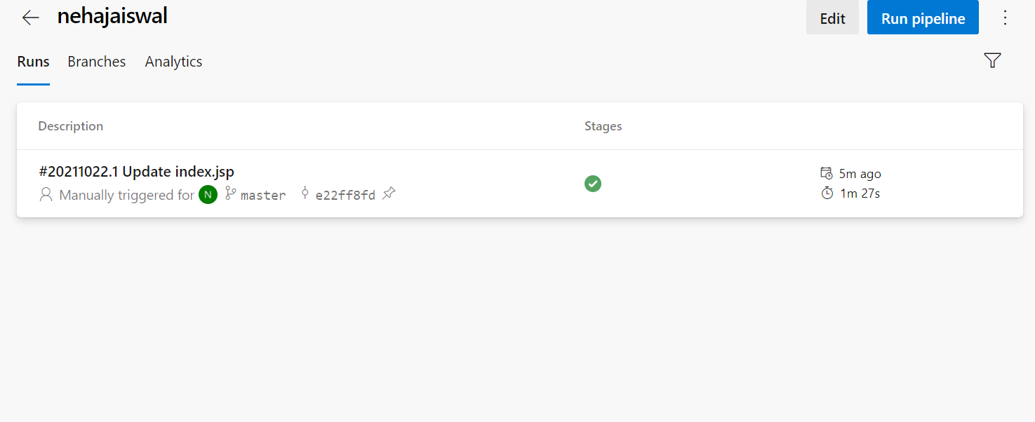

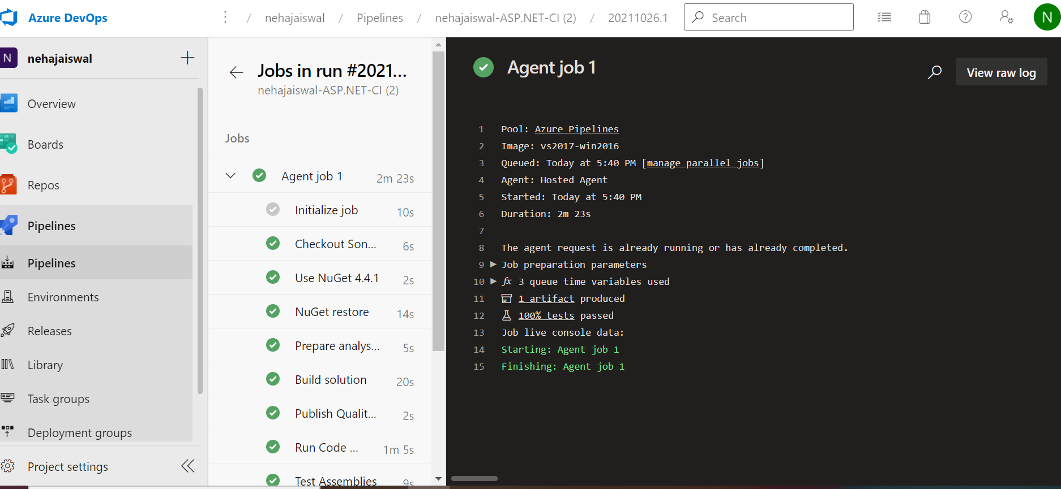

15)and we can see result in sonarcloud like this

